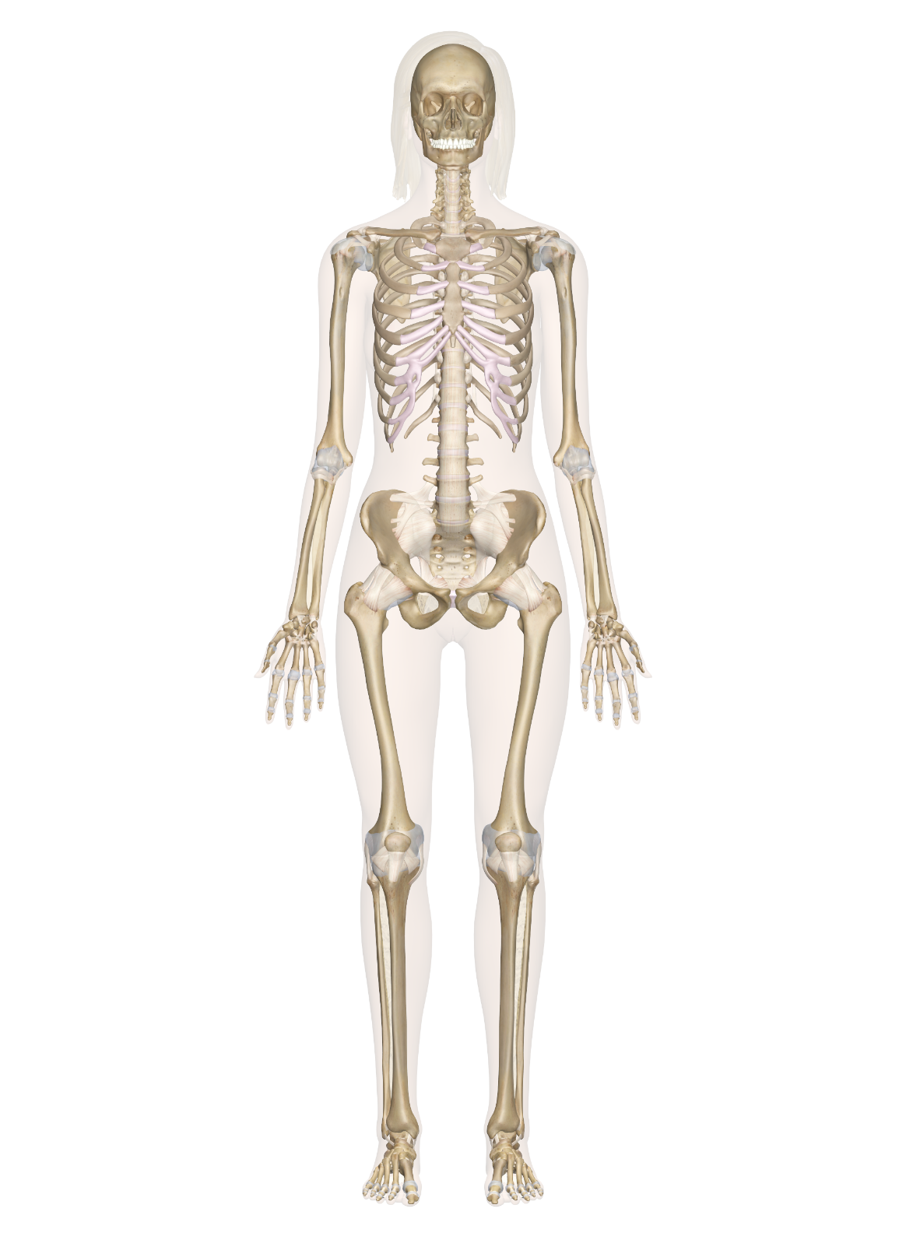

Abstract

In this document, the focus will be on the knowledge of the skeletal system, its individual parts and their functions. This project is a deep research into the skeletal system. All sources used in this work will be written in the reference part of this document

The skeletal system

By SamY

**DEFINITION OF THE SKELETAL SYSTEM**

The skeletal system is the body system composed of bones, cartilages, ligaments and other tissues that perform essential functions for human body. It can also be known as the skeleton. The skeletal system in an adult body is made up of 206 individual bones. These bones are arranged into two major divisions:

1. The axial skeleton
2. The appendicular skeleton

**The Axial Skeleton**

The axial skeleton runs along the body’s midline axis and is made up of 80 bones in the following regions:

1. Skull
2. Ribs
3. Sternum
4. Vertebral column
5. Auditory Ossicles
6. Hyoid

**The Appendicular Skeleton**

The appendicular skeleton is made up of 126 bones in the following regions:

1. Upper limbs
2. Lower limbs
3. Pelvic girdle
4. Pectoral (shoulder) girdle

FUNCTIONS OF THE SKELETAL SYSTEM

* The skeletal system works as a support structure for your body.
* It gives the body its shape.
* It allows movement
* It makes blood cells
* It provides protection for organs
* It stores minerals

**THE SKULL**

The skull is the skeleton of the head of a vertebrate forming a bony or cartilaginous case that encloses and protects the brain and chief sense organs and supports the jaws. The skull is composed of 22 bones that are fused together except for the mandible. These 21 fused bones are separate in children to allow the skull and brain to grow, but fuse to give added strength and protection as an adult. The mandible remains as a movable jaw bone and forms the only movable joint in the skull with the temporal bone. The bones of the superior portion of the skull are known as the cranium and protect the brain from damage. The bones of the inferior and anterior portion of the skull are known as facial bones and support the eyes, nose, and mouth.

FUNCTION OF THE SKULL

1. It protects the organs
2. The skull stabilizes the position of the brain, blood vessels, lymph vessels, and nerves through the build-up of its inner surfaces at the meninges.
3. Large areas for muscle attachments are provided on the outer surface of the skull, which is responsible for head movements and facial expressions, such as the frown.
4. The facial bones form the basis for the face and provide openings to digestive and respiratory systems
5. Along with the bones of the skull, the facial bones create protection and support for the sensory organs. i.e. the eyes, mouth, nose, ears.

**THE VERTEBRAL COLUMN**

**LOCATION**: THE FLEXIBLE COLUMN EXTENDING FROM THE NECK TO THE TAIL

The Vertebral column is a series of approximately 33 bones called vertebrae, which are separated by intervertebral discs. The column can be divided into five different regions, with each region characterised by a different vertebral structure. The vertebral column, also called spinal column, spine, or backbone, in vertebrate animals, the flexible column extending from neck to tail, made of a series of bones, the vertebrae.

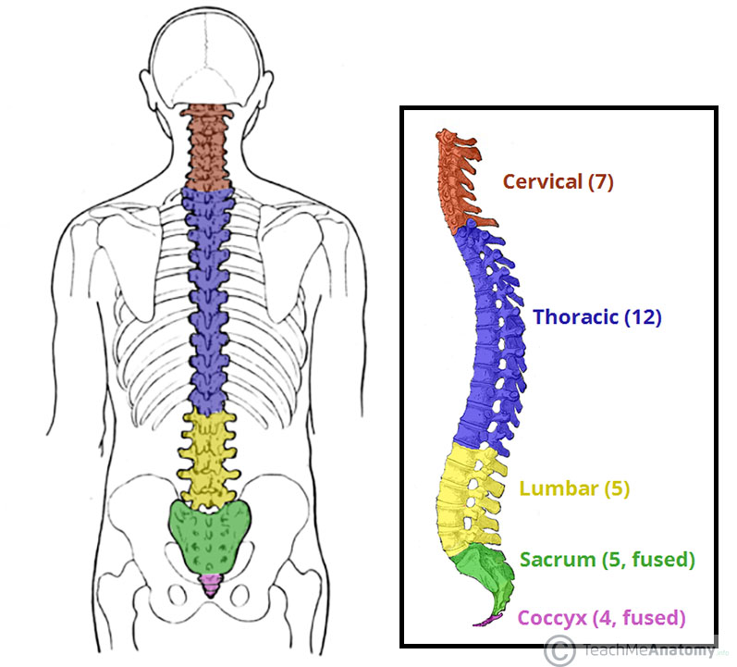

FUNCTIONS OF THE VERTEBRAL COLUMN

* It is the central axis of the skeleton in all vertebrates.
* The vertebrate column provides attachments to muscles
* It supports the trunk
* It protects the spinal cord and nerve roots
* It serves as a site for haemopoiesis.
* It transmits body weight in walking and standing

**RIBS AND STERNUM**

**RIBS**

The ribs are a set of twelve paired bones which form the protective “cage” of the thorax. They articulate with the vertebral column posteriorly, and terminate anteriorly as cartilage (known as costal cartilage). The ribs were coined from a Latin word “costae”, a long curved bone which form the rib cage, part of the axial skeleton. In most tetra-pods, ribs surround the chest, enabling the lungs to expand and thus, facilitate breathing by expanding the chest cavity.

The human rib cage is made up of 12 paired rib bones; each are symmetrically paired on the right and left side. Of all 24 ribs, the first 7 pairs are often labeled as ‘true’. These bones are connected to the costal cartilage, while the five other ‘false’ sets are not. A rib is said to be false if it does not attach to the sternum (the breastbone). The upper three false ribs connect to the costal cartilages of the ribs just above them. The last two false ribs usually have no ventral attachment to anchor them in front and so are called floating, fluctuating or vertebral ribs.

FUNCTIONS OF THE RIBS

* They protect all the vital organs
* They enclose and protect the chest cavity.
* It protects the lungs and heart from any mechanical rear and tear

**THE STERNUM**

The sternum (breast bone) is a long flat bone located in the central part of the chest. It connects to the ribs via cartilage and forms the front of the rib cage, thus, helping to protect the heart, lungs, and major blood vessels from injury.

PARTS OF THE STERNUM

1. Clavicular Notch
2. Manubrium
3. Sternal angle
4. Jugular notch
5. Body
6. Xiphoid process

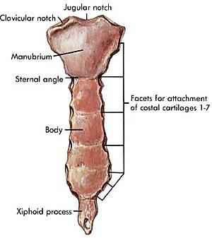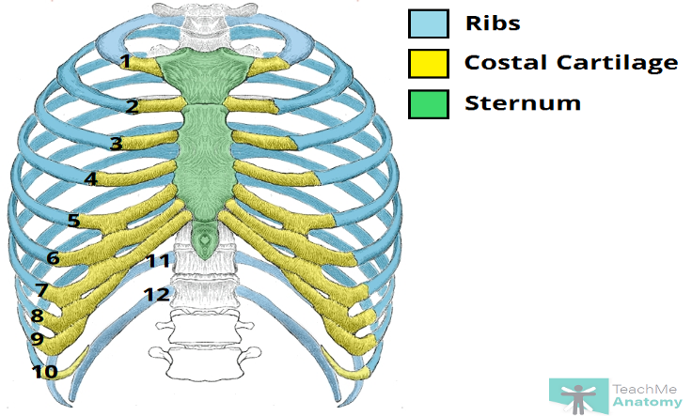

FUNCTIONS OF THE STERNUM

* The sternum along with the ribs, works to protect the organs of your torso, such as your heart, lung and chest blood vessels.
* The sternum also provides a connection point for other parts of your skeletal system, including your collarbone and most of your ribs. Some muscles of your chest and upper abdomen also connect to the sternum.

**THE PECTORAL AND PELVIC GIRDLE**

**PECTORAL GIRDLE**

A pectoral girdle, also referred to as the shoulder girdle, connects your upper limbs to the bones along the axis of your body. We have two pectoral girdles in our bodies.

The pectoral girdle consists of the two bones that make up your shoulder:

1. Clavicle (collarbone)
2. Scapula (shoulder blade)

CLAVICLE BONE

The clavicle or collarbone is an s-shaped bone situated at the front of your body in a horizontal position.

FUNCTIONS OF THE CLAVICLE

1. It supports the shoulder
2. It encourages a full range of motion
3. It protects your nerves and blood vessels that pass between the trunk of your body and your upper limbs.
4. The clavicle provides the only direct connection between your pectoral girdle and axial skeleton.

PARTS OF THE CLAVICLE BONE

The clavicle has three parts:

1. Medial end: this portion of the clavicle attaches to the sternum. The sternal end of the clavicle is triangular and forms the sternoclavicular joint.
2. Lateral end: this portion of the clavicle attaches to the scapula. This flat piece is often referred to as the acromial end, and forms the acromioclavicular joint.
3. Shaft: this is the body of the clavicle.

SCAPULA BONE

The scapula bone or shoulder blade is located at the back of your shoulder. It’s triangular and connects your humerus with your clavicle.

FUNCTION OF THE SCAPULA BONE

The scapula provides an attachment point for a number of muscles in your shoulder and upper limbs to your neck and back.

PARTS OF THE SCAPULA

The scapula is divided into three borders:

1. Medial border (vertebral border), which runs parallel to the thoracic vertebrae
2. Lateral border (auxiliary border)
3. Superior border, the thinnest and shortest of the three borders

It also has two angles:

1. Lateral angle
2. Inferior angle

**PECTORAL GIRDLE JOINTS**

There are four main joints in the pectoral girdle:

|  |  |
| --- | --- |
| 1. Sternoclavicular joint | 1. ii) Scapulothoracic joint |
| 1. Acromioclavicular joint | 1. iv) Glenohumeral joint |

Sternoclavicular Joint

This joint is the point where your clavicle meets your sternum. This joint provides the direct attachment between your upper extremity and axial skeleton, and also allows your clavicle to move in three different planes.

Scapulothoraic Joint

It is also known as the scapulocostal joint; this is where the scapula bone meets the ribs in the back of your chest. This joint relies on surrounding muscle for control.

Acromioclavicular joint

Acromioclavicular joint is the point where your clavicle meets the acromion of the scapula. Similar to the sternoclavicular joint, the acromioclavicular joint encourages motion in three planes.

Glenohumeral joint

Glenohumeral joint also known as the shoulder joint, this is the ball-and-socket connection between the humerus and scapula

**THE PECTORAL GIRDLE**

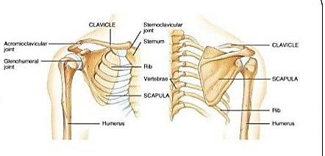

FUNCTIONS OF THE PECTORAL GIRDLE

1. The pectoral girdles are responsible for providing structural support to your shoulder region on the left and right side of your body.
2. They allow for a large range of motion, connecting muscles necessary for shoulder and arm movement. The pectoral girdles on either side of your body aren’t joined together. This allows for your shoulder and arms to move and function independently.

**PELVIC GIRDLE (Pelvis)**

The pelvic girdle is a ring-like bony structure, located in the lower part of the trunk. It is formed by the hip bones, sacrum and coccyx. It connects the axial skeleton to the lower limbs.

Structure of The Pelvic girdle

There are four articulations within the pelvic girdle:

1. Sacroiliac joints (x2)-Between the ilium of the hip bones, and the sacrum
2. Sacrococcygeal Symphasis-between the sacrum and the coccyx
3. Pubic Symphasis-Between the pubis bodies of the two hip bones.

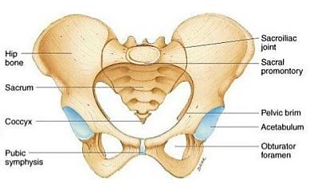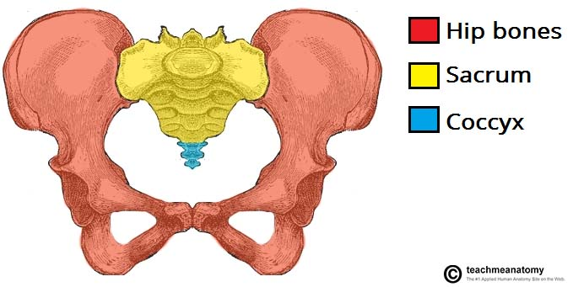

Functions of the Pelvic girdle

* Transfer of weight
* Provides attachment
* Contains and protects the abdominopelvic and pelvic viscera

**HIND AND FORE LIMBS**

**Hind Limbs**

The lower limb consists of the thigh (the upper leg), the leg (the lower leg), and the foot. The thigh consists of a single bone, the femur. The leg consists of two long bones, the tibia and fibula, and the sesamoid bone, the patella, that serves as the knee cap. The foot consists of 26 bones, which are grouped into the tarsals, metatarsals, and phalanges.

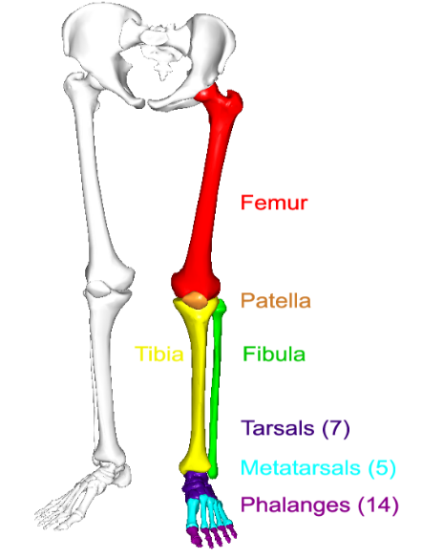

Bones of the Foot

The calcaneus is the heel bone, and the talus bone forms the ankle joint with the tibia and fibula. The calcaneus and tarsus are two of the seven tarsal bones that are posterior to the first long bones of the foot, the metatarsal bones. The bones of the toes are phalanges, the same name used for finger bones. The bones of the foot are shown in the diagram below.

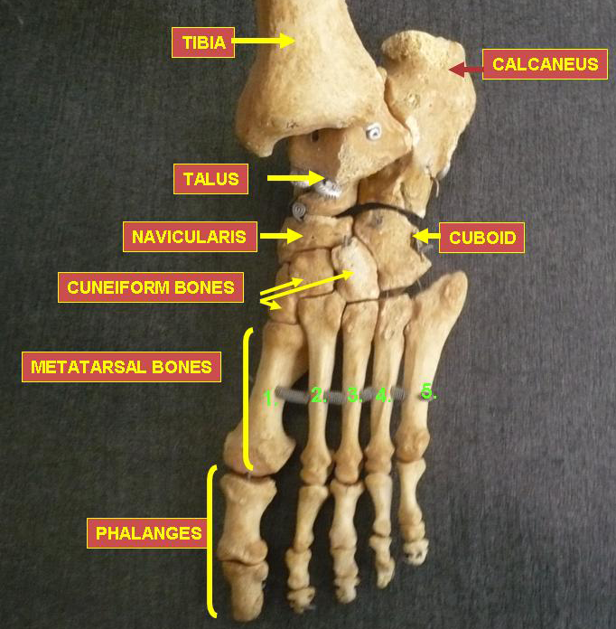

**Fore Limbs**

The upper limb consists of the arm (upper arm), the forearm (the lower arm), and the hand. The arm consists of a single bone, the humerus bone. The forearm consists of two bones, the ulna and radius. And the hand consists of 27 bones, which are grouped into the phalanges, metacarpals, and carpals.

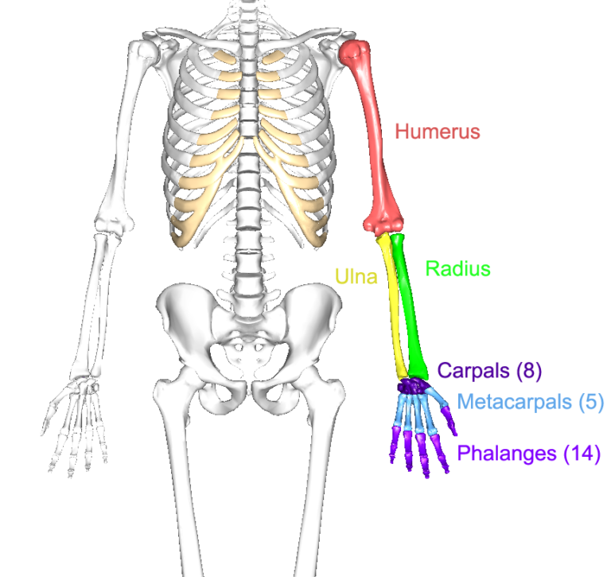

The metacarpals are five individual bones that are wrapped in muscle and collective tissue to create a single solid mass that serves as the palm of the hand. They are numbered I – V, starting with the metacarpal under the thumb and moving sequentially to the little finger. Metacarpals are individually named according to the hand they come from and their number. So the metacarpal under the little finger is named left metacarpal V.

There are 14 bones that make up the fingers. All are called phalanges (singular is phalanx). Each finger is made up of three phalanges, labeled the proximal, middle and distal phalanges as you move farther out from the metacarpals. Each thumb only has two phalanges, labeled proximal and distal. The phalanges are numbered I through V, like the metacarpals. Each phalanx then is named according to which hand it comes from, which number it is, and whether it is proximal, middle, or distal. So the second phalanx on the pointing finger is the left medial phalanx II.

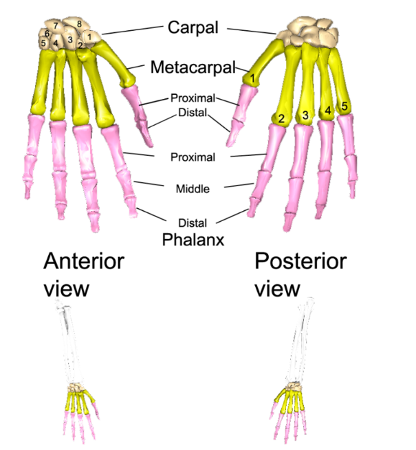

Functions of the Hind and Fore Limbs

* Limbs are used for locomotion, such as walking
* They are used to carry and manipulate objects

**JOINTS**

Joints hold the skeleton together and support movement. There are two ways to categorize joints. The first is by joint function, also referred to as range of motion. The second way to categorize joints is by the material that holds the bones of the joints together; that is an organization of joints by structure.

Joints in the human skeleton can be grouped by function (range of motion) and by structure (material). Here are some joints and their categorizations.

|  |  |
| --- | --- |
| Based on Range of Motion | Based on Material |
| Immovable fibrous joints | fibrous joints |
| Full movement synovial capsule hinge joint | synovial capsule hinge joint |
| Some movement cartilaginous joint | cartilaginous joint |

Joint types can be categorized by range of motion

**Immovable joints** (called **synarthroses**) include skull sutures, the articulations between the teeth and the mandible, and the joint found between the first pair of ribs and the sternum. Examples of **joints allowing slight** movement (called **amphiarthroses**) include the distal joint between the tibia and the fibula and the pubic symphysis of the pelvic girdle. **Joints allowing full movement** (called **diarthroses**) include many bone articulations in the upper and lower limbs. Examples of these include the elbow, shoulder, and ankle.

Joints Can Be Grouped by Their Structure into Fibrous, Cartilaginous, and Synovial Joints

**Fibrous Joints**: Between the articulations of fibrous joints is thick connective tissue, which is why most (but not all) fibrous joints are immovable (synarthroses). There are three types of fibrous joints:

(1) Sutures are non-moving joints that connect bones of the skull. These joints have serrated edges that lock together with fibers of connective tissue.

(2) The fibrous articulations between the teeth and the mandible or maxilla are called gomphoses and are also immovable.

(3) A syndesmosis is a joint in which a ligament connects two bones, allowing for a little movement (amphiarthroses). The distal joint between the tibia and fibula is an example of a syndesmosis.

**Cartilaginous Joints**: Joints that unite bones with cartilage are called cartilaginous joints. There are two types of cartilaginous joints:

(1) A synchrondosis is an immovable cartilaginous joint. One example is the joint between the first pair of ribs and the sternum.

(2) A symphysis consists of a compressible fibro-cartilaginous pad that connects two bones. This type of joint allows for some movement. The hip bones, connected by the pubic symphysis, and the vertebrae, connected by intervertebral discs, are two examples of symphyses.

**Synovial joints** are characterized by the presence of an articular capsule between the two joined bones. Bone surfaces at synovial joints are protected by a coating of articular cartilage. Synovial joints are often supported and reinforced by surrounding ligaments, which limit movement to prevent injury. There are six types of synovial joints:

(1) Gliding joints move against each other on a single plane. Major gliding joints include the intervertebral joints and the bones of the wrists and ankles.

(2) Hinge joints move on just one axis. These joints allow for flexion and extension. Major hinge joints include the elbow and finger joints.

(3) A pivot joint provides rotation. At the top of the spine, the atlas and axis form a pivot joint that allows for rotation of the head.

(4) A condyloid joint allows for circular motion, flexion, and extension. The wrist joint between the radius and the carpal bones is an example of a condyloid joint.

(5) A saddle joint allows for flexion, extension, and other movements, but no rotation. In the hand, the thumb’s saddle joint (between the first metacarpal and the trapezium) lets the thumb cross over the palm, making it opposable.

(6) The ball-and-socket joint is a freely moving joint that can rotate on any axis. The hip and shoulder joints are examples of ball and socket joints.

Functions of Joints

* To allow mobility of the skeletal system
* To provide a protective enclosure for vital organs
* Joints are responsible for movement

REFERENCES

1. Britannica
2. Wikipedia
3. Visiblebody.com
4. Teachmeanatomy